Software Design Document

<Sydney Stayz>

Joel Rosin, Daniel Soulavy, Rahul Gupta

Table of Contents

1.0 System Vision 2

1.1 Problem Background 3

1.2 System Overview 3

1.3 Potential Benefits 5

2.0 Requirements 6

2.1 User Requirements 7

2.2 Software Requirements 7

2.3 Use Cases & Use Case Diagrams 8

3.0 Software Design and System Components 13

3.1 Software Design 14

3.2 System Components 14

3.2.1 Functions 14

3.2.2 Data Structures / Data Sources 15

3.2.3 Detailed Design 16

4.0 User Interface Design 17

4.1 Structural Design 18

4.2 Visual Design 21

# System Vision

## Problem Background

Recently, the travel and hospitality industry had experienced transformations with the development of Airbnb, a platform which offers an array of accommodation options for individuals seeking alternatives to traditional hotels. The introduction of Airbnb has led to a rise in listings within Sydney, creating a need for comprehensive insights into the local market. As the number of Airbnb’s in Sydney continues to rise, the need for a user-friendly, data-driven solution becomes increasingly apparent, something which allows property owners, guests, and stakeholders to navigate the large amount of data available on the platform with ease.

The Sydney Stayz project strives to address this need by developing an intuitive data analysis tool tailored to the Sydney area. This tool is poised to leverage a graphical user interface to delve into data derived from the collection of Airbnb listings. The main goal is to allow users to make informed decisions by gaining insights into market questions, like pricing, customer opinions related to cleanliness and amenities, occupancy rates, and the popularity of stay options across various suburbs.

## System Overview

Listings Explorer feature

The Suburb Explorer feature is an element of the Sydney Stayz Application data analysis and visualisation tool, tailored to give users insightful information about Airbnb listings within specific suburbs in Sydney. This feature allows users to make decisions by offering a understanding of metrics and trends seen with different localities.

Key Functionality:

* Selection Parameters: Users can input a period of dates and choose a suburb of interest. This selection allows users to see data for their desired timeframe and location.
* Interactive Interface: The user-friendly interface allows users to explore different suburbs and timeframes, enabling seamless exploration of the Airbnb market in Sydney.

Price Distribution Chart Feature

The Price Distribution Chart tool is designed to offer users insights into the pricing of Airbnb listings across Sydney during specific timeframes. By presenting the distribution of property prices, this feature helps users to identify pricing trends, enabling them to make better informed booking decisions.

Key Functionality:

* Date Range Selection: Users can specify a period of dates for analysis, allowing them to focus on specific dates.
* Suburb selection: allows users to select two different Sydney suburbs for comparison.
* Price Range: Users can specify a range of prices to focus on to narrow down the data to a specific price range of interest
* Visual Representation: The feature creates graphical representations of the distribution of property prices using a bar chart. These visualisations highlight the range of prices, providing users with clear understandings of the pricing.
* Decision Support: The insights gained from the price distribution chart can help guide users in identifying optimal booking times based on pricing.

Keyword Search Feature

The Keyword Search feature enables efficient property discovery based on specific amenities and features for users. Users can input keywords to filter listings during chosen timeframes.

Key Functionality:

* Keyword Input: Users can input keywords related to amenities they desire during their stay, like as "air-conditioning," "pool," or "pet."
* Date range input: users can select a specific date range to refine their results
* Listing Retrieval: The tool retrieves and presents listings which match the specified keywords.

Cleanliness Comment Analyser Feature

The Cleanliness Comment Analyser feature analyses user comments related to cleanliness from customer reviews. This feature provides insights into guest feelings regarding cleanliness, influencing to more informed decision-making for potential guests.

Key Functionality:

* Comment Analysis: The feature identifies customer reviews related to predefined cleanliness-related keywords, such as "clean," "tidy," and "hygienic."
* Date range input: users can select a specific date range to refine their results
* Insight Generation: Property owners can use this data to improve property cleanliness standards, while guests can determine the cleanliness before booking.

Top Rated Suburbs and Property Type Feature

The Top-Rated Suburbs and Properties feature gives insights by the most highly rated suburbs and properties. This analysis gives both guests and property owners information about popular areas and accommodations in Sydney.

Key Functionality:

* Rating Analysis: The tool analyses user ratings to find the top-rated suburbs and properties during the chosen period.
* Date range input: users can select a specific date range to refine their results
* Decision Guidance: Guests gain insights into highly sought-after locations and properties, whilst property owners can adjust their accommodations based on user preferences.

## Potential Benefits

The Sydney Stayz tool offers potential benefits within the Sydney Airbnb market. These benefits stem from the tool's features which provide insights into the current short-term rental market:

More Informed Decision-Making:

* Suburb Explorer: Users can make informed decisions based on metrics about specific suburbs, this helps them choose the most suitable accommodation or helps to optimise their property listings.
* Price Distribution Chart: Users can identify price trends, allowing them to plan trips during cheaper periods of the year.
* Keyword Search: Users can find properties that have their desired amenities, improving their booking experience.

Enhanced Guest Experience:

* Keyword Search: Users can discover properties that align with their preferences more easily, leading to a better holiday experience.
* Top Rated Suburbs and Property Type: Users can choose highly rated locations and accommodations, making it easier to find areas more people find appealing.

Strategic Insights:

* Top Rated Suburbs and Property Type: Property owners can identify stay trends and preferences, guiding their investment strategies.
* Price Distribution Chart: Property owners can adapt pricing strategies based on trends, maximising their potential revenue.

Time Saving:

* Suburb Explorer: Users can quickly access metrics for specific suburbs and timeframes, saving time when trying to find a property to stay at.
* Keyword Search: Users can find properties with their desired amenities, making the search process easier.

Competitive Advantage:

* Property owners can gain a competitive advantage by positioning their offerings with guest preferences and current market trends.

# Requirements

## User Requirements

For the unique folks who make up our audience – be it the passionate Airbnb property owners in Sydney, the eager travellers searching for their next Airbnb adventure, or the analytical stakeholders exploring the Airbnb Sydney market – we have sketched out the following expectations:

1. **Property Owners**:

* An interactive map of Sydney's vibrant neighbourhoods to keep an eye on local trends and tailor their offerings accordingly.
* A candid mirror to their property's cleanliness, reflecting guest reviews.
* A glimpse into the most-loved suburbs and accommodations, guiding their next steps.
* Insights into the heartbeat of Sydney's Airbnb pricing, helping them strike the right balance.

1. **Guests**:

* A toolbox to find properties fitting their unique desires, whether it's a Jacuzzi or a sunlit reading nook.
* A virtual tour guide sharing the ins and outs of Sydney's suburbs, helping them choose the perfect stay.
* A crystal ball revealing the highs and lows of Sydney's Airbnb prices.
* A compass pointing to the crème de la crème of suburbs and properties.

1. **Stakeholders**:

* A treasure trove of data offering a panoramic view of Sydney's Airbnb landscape.
* A detective's toolkit to sift through the numbers and unveil actionable narratives about the market.

## Software Requirements

Updated suburb explorer to listings explorer. Added that each tool allows for date range selection

R1. **Listing Explorer Feature**:

- R1.1 The tool shall allow users to select a property type.

- R1.2 The tool shall enable users to select a suburb of interest.

-R1.3 The tool shall allow for date range selection

R2. **Price Distribution Chart Feature**:

- R2.1 The tool shall provide suburb selection functionality.

- R2.2 The feature shall graphically represent the distribution of property prices.

-R2.3 The tool shall allow for date range selection

R3. **Keyword Search Feature**:

- R3.1 The tool shall accept date range input from users.

- R3.2 The tool shall display listings matching the specified date range if property is available.

-R3.3 The tool shall allow for a keyword to be input to display properties with that specific amenity

R4. **Cleanliness Comment Analyser Feature**:

- R4.1 The feature shall identify customer reviews using predefined cleanliness-related keywords.

-R4.2 The tool shall allow for date range selection

R5. **Top Rated Suburbs and Property Type Feature**:

- R5.1 The tool shall analyse user ratings to identify top-rated suburbs and properties.

- R5.2 The tool shall provide insights based on the rating analysis.

-R5.3 The tool shall allow for date range selection

## Use Cases & Use Case Diagrams

Use case for Sydney Stayz

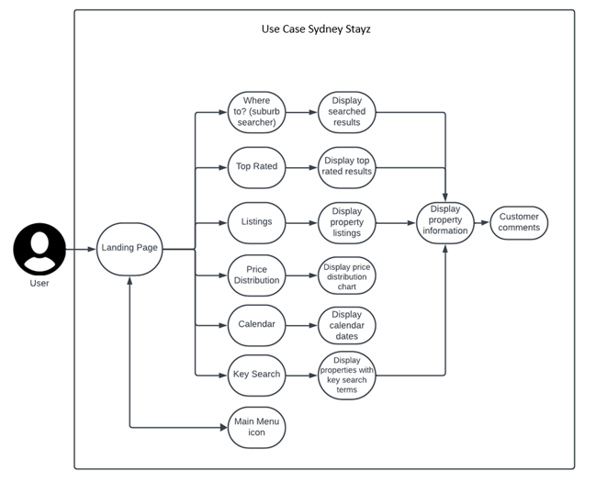

**Use Cases Diagram:**

Visualize a diagram with the following interactions:

* **Guest (Actor)**:
* Search for Airbnb Properties Using Keywords
* Explore Suburbs with the Suburb Explorer
* View Price Distribution Chart for a Date Range
* **Property Owner (Actor)**:
* Analyse Property Cleanliness Feedback
* Explore Top Rated Suburbs and Property Types
* Analyse Price Distribution for a Date Range

**Detailed Use Cases:**

**Use Case ID:** UC-001  
**Use Case Name:** Search for Airbnb Properties Using Keywords  
**Brief Description:** Guests can input keywords to find specific Airbnb properties that match their requirements.  
**Actors:** Guest  
**Flow of Events:**

1. Guest opens the tool.
2. Uses the keyword search feature to input specific amenities or property features.
3. A list of properties that match the keywords is displayed.
4. Guests can select a property to view detailed information.

**Triggers:** Guest's intent to find a property based on specific amenities/features.

**Preconditions:**  
Listings with the desired keywords are available.

**Postconditions:**  
Guest is presented with a list of properties that match the keywords.

**Alternate Flow:**  
If no properties match the keywords, a message is displayed suggesting alternative keywords or properties.

**Use Case ID:** UC-002  
**Use Case Name:** Explore Suburbs with the Suburb Explorer  
**Brief Description:** Guests can explore different suburbs to get a feel for the amenities, attractions, and properties available.  
**Actors:** Guest  
**Flow of Events:**

1. Guest accesses the Listings Explorer feature.
2. The tool presents a list of suburbs with relevant data such as amenities, attractions, and top properties.
3. Guest can select a suburb to delve deeper into what it offers.
4. Listings, attractions, and any relevant data about the selected suburb are displayed.

**Triggers:** Guest's intent to familiarize themselves with various suburbs.  
**Preconditions:**  
Database contains data regarding different suburbs.

**Postconditions:**  
Guest has a better understanding of what each suburb offers.

**Alternate Flow:**  
If data for the selected suburb is unavailable, a message informs the guest and suggests exploring other suburbs.

**Use Case ID:** UC-003  
**Use Case Name:** View Price Distribution Chart for a Date Range  
**Brief Description:** Guests can view a chart that displays the distribution of property prices for a specific date range.  
**Actors:** Guest  
**Flow of Events:**

1. Guest selects the date range they are interested in.
2. Tool fetches and displays a distribution chart showing the range of property prices for the selected date range.
3. Guests can interact with the chart, possibly hovering over data points for detailed information.

**Triggers:** Guest's intent to understand property pricing for their planned stay dates.  
**Preconditions:**

The tool has access to pricing data for the selected date range.  
**Postconditions:**  
Guest gains insights into property pricing for the selected dates.  
**Alternate Flow:**  
If pricing data for the selected dates is unavailable, the tool notifies the guest and suggests alternate date ranges.

**Use Case ID:** UC-004  
**Use Case Name:** Analyse Property Cleanliness Feedback  
**Brief Description:** Property owners can analyse guest feedback related to the cleanliness of their properties.  
**Actors:** Property Owner  
**Flow of Events:**

1. Property owner opens the tool.
2. Navigates to the Cleanliness Comment Analyser.
3. Tool displays feedback related to cleanliness for properties.
4. Property owner reviews feedback to identify areas of improvement.

**Triggers:** Property owner's desire to understand guest feedback on cleanliness.  
**Preconditions:**  
There are reviews for the property owner's listings.

**Postconditions:**  
Property owner has clarity on cleanliness feedback.  
**Alternate Flow:**  
If there are no cleanliness-related reviews for the properties, a message informs the property owner.

**Use Case ID:** UC-005  
**Use Case Name:** Explore Top Rated Suburbs and Property Types  
**Brief Description:** Property owners and guests can view the top-rated suburbs and property types based on user ratings.  
**Actors:** Property Owner, Guest  
**Flow of Events:**

1. User accesses the Top-Rated Suburbs and Property Type feature.
2. Tool displays a ranked list of suburbs and property types based on user ratings.
3. User can select a suburb or property type for more detailed insights.

**Triggers:** User's intent to discover popular suburbs and property types.

**Preconditions:**  
There are sufficient user ratings to rank suburbs and property types.  
**Postconditions:**  
User gains insights into the most highly rated suburbs and properties.  
**Alternate Flow:**  
If there aren't enough ratings, a message informs the user and suggests alternate suburbs or properties.

**Use Case ID:** UC-006  
**Use Case Name:** Analyse Price Distribution for a Date Range  
**Brief Description:** Property owners can view and analyse how their property's price compares to others in the market for a specific date range.  
 **Actors:** Property Owner  
 **Flow of Events:**

1. Property owner selects the date range they want to analyse.
2. The tool fetches and presents a distribution chart showing property prices, highlighting where the owner's property stands.
3. Property owners can interact with the chart to understand market trends and adjust their pricing strategy.

**Triggers:** Property owner's intent to understand their property's pricing position in the market.  
**Preconditions:**  
The tool has access to pricing data, including that of the property owner's listing, for the selected date range.  
**Postconditions:**  
Property owner gains insights into the market pricing and can adjust their pricing strategy if needed.  
**Alternate Flow:**  
If pricing data for the selected date range is unavailable, the tool notifies the property owner and may suggest an alternate date range.

# Software Design and System Components

## Software Design

Lucidchart has a limit on shapes per page, please excuse the markup that was necessary to complete this flowchart.

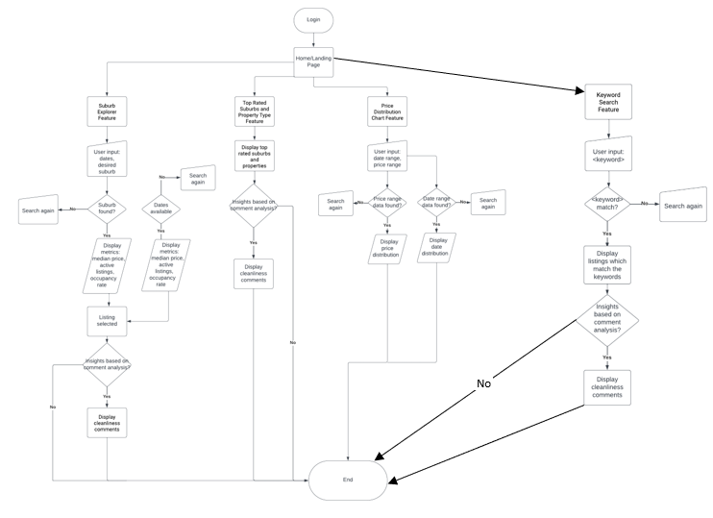

## System Components

### Functions

Updated System components inputs and names to reflect accurately to the python files names and functionality. Removal of functions that weren’t implemented like median price and occupancy rate.

**Listings:**

* Description: Loads Airbnb listing data from the data source.
* Input Parameters: date range, suburb selection.
* Side Effects: Loads data into memory.
* Return Value: List of listing objects.

**price_distribution**

* Description: Generates a chart showing the distribution of property prices.
* Input Parameters: property objects, date range, price range.
* Side Effects: None.
* Return Value: Chart image (data).

**Keyword_search**

* Description: Filters listings based on specified input keywords.
* Input Parameters: keyword(s).
* Side Effects: None.
* Return Value: Filtered list of listing objects.

**cleanliness_analyser**

* Description: Analyses data for user review comments related to cleanliness-keywords.
* Input Parameters: List of review objects.
* Side Effects: None.
* Return Value: list of comments containing cleanliness-related keywords.

**top_rated**

* Description: Identifies top-rated suburbs and property types.
* Input Parameters: Date range, property type, suburb selection.
* Side Effects: None.
* Return Value: List of top-rated properties in suburb.

### Data Structures / Data Sources

Updated what functions were using data structure types and data sources.

**Data Structure: List (Array)**

* Description: Lists are used to store collections of objects like property listings and reviews.
* Data Members: List of property objects, list of review objects.
* Functions Using It: Many functions like Keyword_search, cleanliness_analyser, etc.

**Data Structure: Dictionary**

* Description: Dictionaries are used to store key-value pairs, such as “top-rated suburbs and property types”.
* Data Members: Dictionary of top-rated suburbs and property types.
* Functions Using It: top_rated.

**Data Structure: Chart Data**

* Description: Data structure to store information for generating charts.
* Data Members: Data points for x and y axis values, chart type.
* Functions Using It: price_distribution.

**External Data Source: Airbnb Listing Data**

* Description: External data source which contains information about the Airbnb listings.
* Data Members: Listing ID, property details, amenities, price, occupancy rate.
* Functions Using It: listings, keyword_search, price_distribution, top_rated, cleanliness_analyser.

**External Data Source: Airbnb Review Data**

* Description: External data source containing customer reviews of Airbnb listings.
* Data Members: Listing ID, review details, cleanliness feedback, rating.
* Functions Using It: cleanliness_analyser

### Detailed Design

Removed algorithms for calculating median price and occupancy rate

**Algorithm: Analyse Cleanliness Comments**

* This algorithm analyses user reviews to highlight cleanliness-related comments.
* It creates a dictionary to store number of counts of specific keywords.
* For each review, it iterates through the list of cleanliness keywords to check if any of those keywords appear in the reviewer's comment.
* If a keyword is found, the algorithm the count increments for that keyword in the dictionary.
* The result is a dictionary that shows how many times each keyword appears in the reviews and showcases each of those reviews for users to read.

**Algorithm: Identify Top Rated Suburbs and Property Types**

* This algorithm identifies the top-rated suburbs and properties based on reviews within a specified date range.
* It initialises dictionaries to store ratings for each suburb and property.
* For each review within the date range, it adds the review's rating to the suburbs and property rating in the dictionaries.
* it then sorts the suburb ratings and property's ratings in descending order.
* It selects the top-rated suburbs and properties based on the sorted results and returns these lists to view.

# User Interface Design

Updated information about tool used for GUI, wxFormBuilder was added to this implementaion.

For the user interface design for the Airbnb analysis software, the use of wxFormBuilder was employed. The wxFormBuilder program allowed the creation of visual representations of the Sydney Stayz user interface and to show how it will be interacted with between its various components. The design stage aims to outline the application layout, showcase feature design, and highlight the flow of the application in a clear and intuitive manner.

During the design process, several key findings influenced our interface design decisions:

* **User-Centric Approach:** We focused on the creation of a user-friendly interface that caters to all users. Intuitive navigation, clear and easy to read data presentation, and interactive features were prioritised to enhance the user experience.
* **Data Visualisation:** Given the nature of the software, effective and easy to read data visualisation was essential. We aimed to present insights through charts and lists, making complex data easy to understand for all users.
* **Functional Clarity:** Each feature's purpose was defined and placed prominently in the interface. It was crucial to convey the functionalities of each clearly.
* **Input Flexibility:** The interface design allows users to input dates, suburbs and keywords flexibly.
* **Consistency and Navigation:** Consistent design elements ensure that users can switch between different features while maintaining consistency with the interface.

## Structural Design

Top Navigation bar was removed due to difference in layout. Mobile changed to desktop design. Main Menu section updated to reflect accurate button selections. Sub Icon Section removed, due to GUI changes.

The structural design of the Airbnb analysis software revolves around creating an intuitive and organized user experience that facilitates efficient navigation, easy information access, and clear interaction. The design choices aim to enhance usability, provide a logical hierarchy, and ensure a seamless flow of user interactions.

**Interface Structure and Hierarchy:**

**Main Menu Section:**

The main icons, including Top Rated, Listings, Price Distribution, and Keyword Search, are positioned centrally on the screen. These bold and distinct buttons guide users to core functionalities related to property search and analysis.

**Property Listing Display:**

The central area of the interface is dedicated to showcasing the property input information. Placing the property information prominently captures users' attention and makes the list of listings visually appealing and easier to read.

**Top Rated Information:**

Users find selection options located central, one about the selected property type and the other is the neighbourhood, the displays the information below after selections have been made. This arrangement offers a natural progression from selection to informational content.

**User Comments analysis:**

Below the property information, the cleanliness analysis section presents comments from previous visitors. This segregated placement allows users to access cleanliness related reviews below the listings list without overwhelming the main content area.

**Navigation Section:**

At the top of the interface, each page has a back to main menu button which offers a consistent way to navigate back to other functionalities:

**Information Grouping and Navigation:**

**Hierarchical Listing Information:** Property information and comments are structured hierarchically, with property details providing core information, followed by user comments for deeper insights.

**Logical Flow:** The progression from the main menu to application features follows a logical user flow, guiding users through the process of locating, evaluating, and learning more about listings.

**Keyword Navigation:** The keywords navigation icon enables users to customise their search experience, grouping relevant listings based on their preferences.

**User-Centric Focus:** by keeping the user interface the same throughout the application is allows for an easier to use experience, making the product more inviting and user-friendly.

**Justification of Design Choices:**

**User-Friendly Interaction:** The bold main menu buttons provide a clear visual cue, guiding users to the most critical features of property search and analysis.

**Visual Emphasis:** Placing the property information centrally draws immediate attention, as graphical images and tables are a vital part of property evaluation.

**Easy Information Access:** Segregating user cleanliness comments prevents information overload and ensures easy access to visitor experiences.

**Efficient Navigation:** Grouping sub buttons together allows users to access secondary actions without disrupting the main user flow.

## Visual Design

The overall visual design and layout changed as more information was gathered about how to display the information on the program. Design changed from mobile application to desktop application, due to the way the data is displayed made it very difficult to read on a small device. The newer version of the design allows for more user selected options on each page, increasing the simplicity of design and making the generated data more of a focus.

**Main Menu Page**

The design for the landing page is intended to be simplistic and user-friendly. User should be able to easily navigate to the desired pages that they wish to pull data from. The page has a contrast between the header being a darker shade of grey, then the main page transitions to a lighter shade of grey with black text. This colour scheme will stay consistent throughout the entire software application, as the group felt that the colours shouldn’t be the main thing that sticks out the most in a data analysis application.

. The following component buttons are conveniently placed in the middle header:

* Listings
* Top Rated
* Price Distribution
* Keyword Search

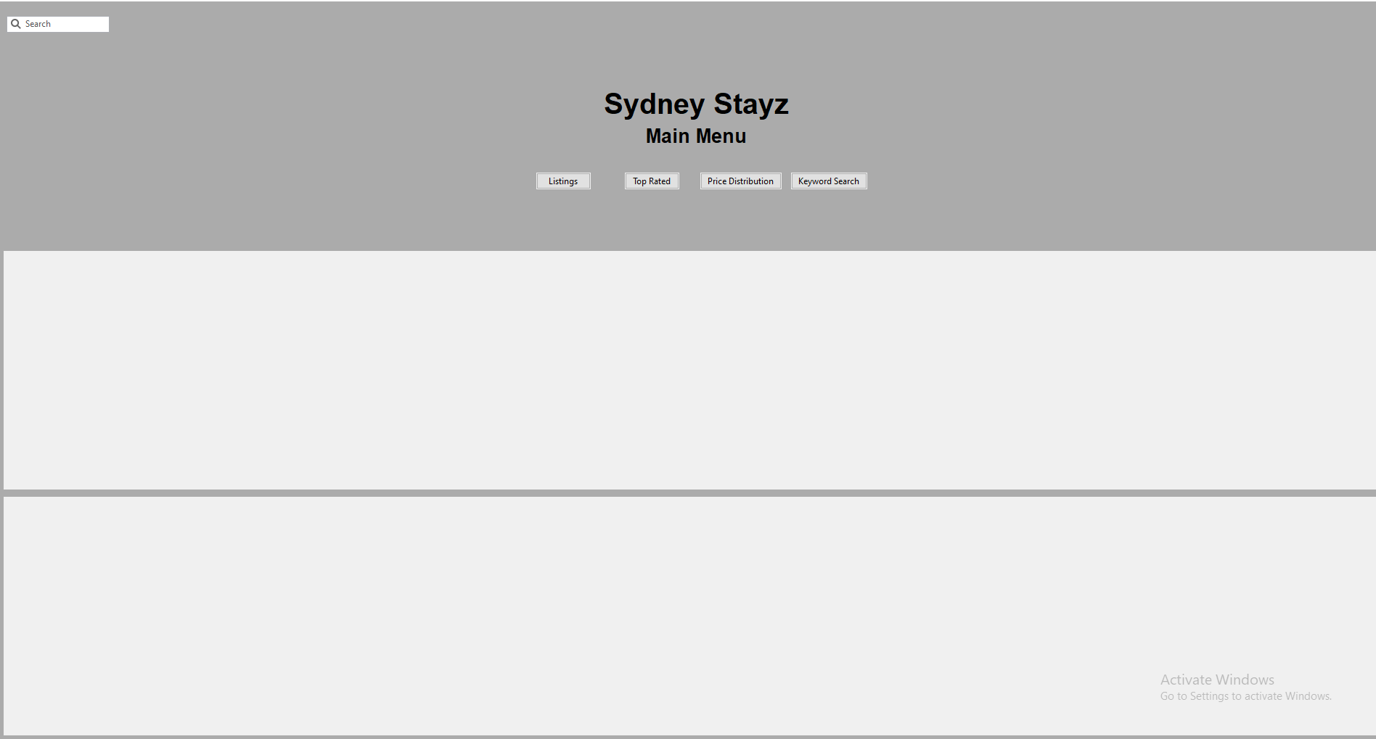

**Listings**

The first component is listings. The listings page consists of a pop-up table which handles all data input and output, a Back To Main Menu button which takes the user back to the main menu landing page, and finally a Listings button which opens the pop-up table again if it has been closed. The colour scheme is consistent with the main menu page.

The pop-up table that handles the data is designed to be intuitive and user-friendly. The process for data input is intentionally designed to be a step-by-step process. Inside the pop up table there is a sub window where the populated data is visualised. This sub window has padding on all 4 sides (up, down, left, right) for a more visually appealing look so the data doesn’t stretch from screen to screen.

The input widgets on the listings table consist of:

* A neighbourhood widget drop down box
* An optional property type widget drop down box
* Date range widget with an integrated calendar inside the widget

To populate the table with the chosen filtered data, user hits the “Update Table” button which is conveniently placed in the next column over from the drop-down boxes.

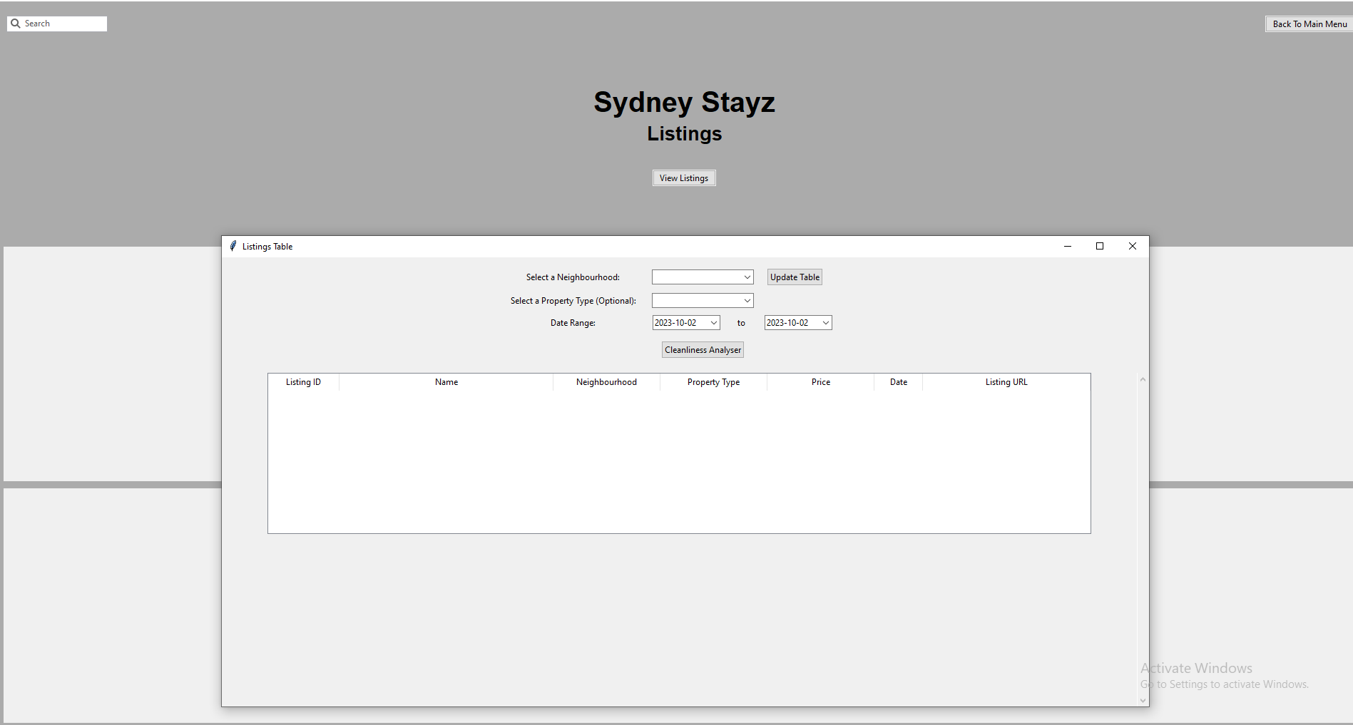

Finally, a button named “Cleanliness Analyzer” is positioned under the input widgets. This button is to filter comments that are related to cleanliness. When the button is hit (and there’s data input inside the widgets) the cleanliness comment data is appended below the listings data.

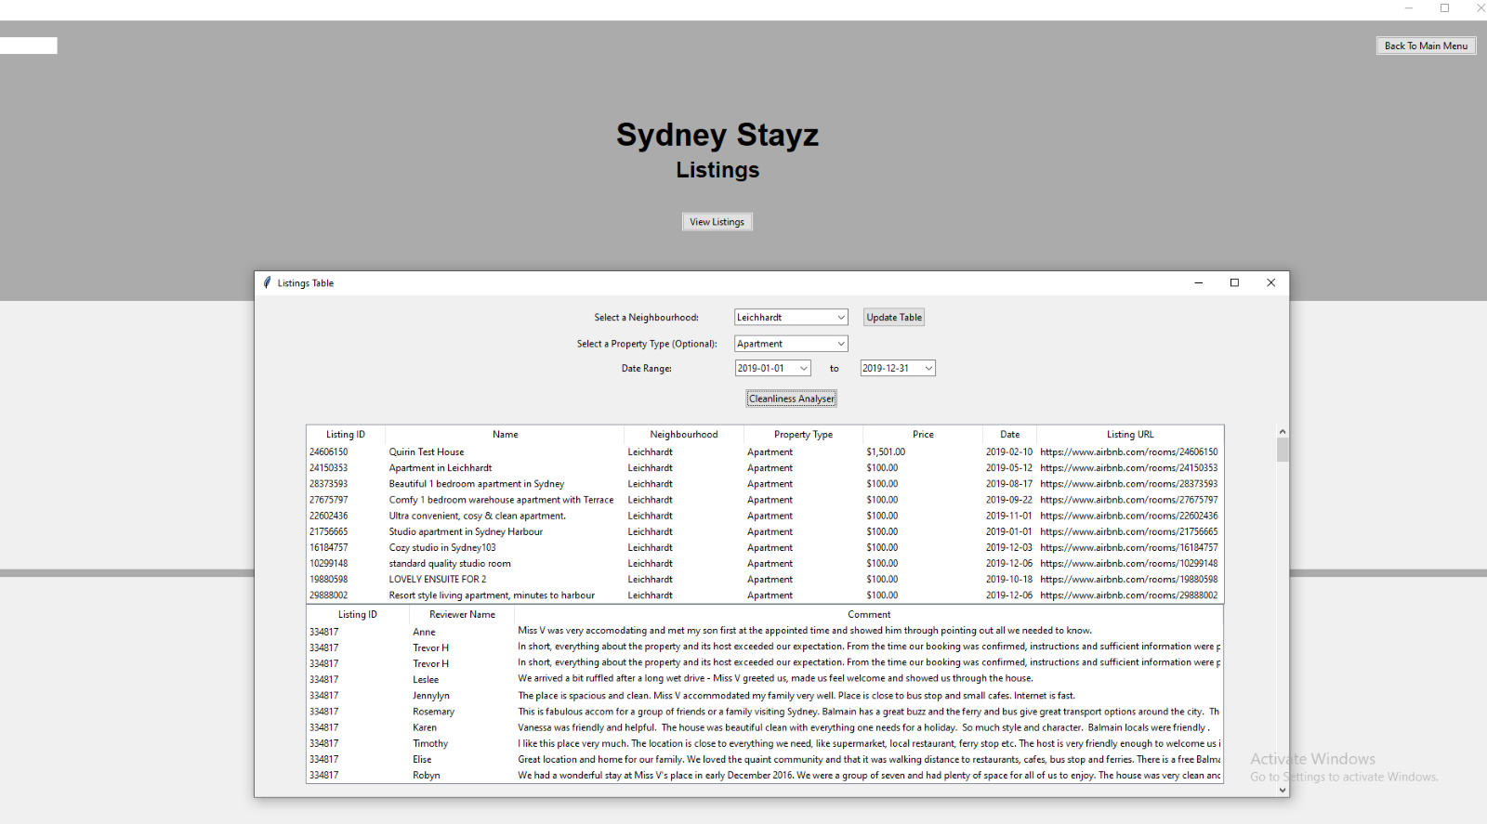

**Top Rated**

The top rated component page consist of two buttons, a “back to main menu” button which takes user back to the main menu page, and a “view top rated properties” button which opens the pop up table if it's been closed. The pop up table consists of 3 input widgets:

* A neighbourhood widget drop down box
* An optional property type widget drop down box
* Date range widget with an integrated calendar inside

The pop-up table that handles the data is designed to be intuitive and user-friendly. The process for data input is intentionally designed to be a step-by-step process. Inside the pop up table there is a sub window where the populated data is visualised. This sub window has padding on all 4 sides (up, down, left, right) for a more visually appealing look so the data doesn’t stretch from screen to screen.

To populate the table with the chosen filtered data, user hits the “Update Table” button which is conveniently placed in the next column over from the drop-down boxes.

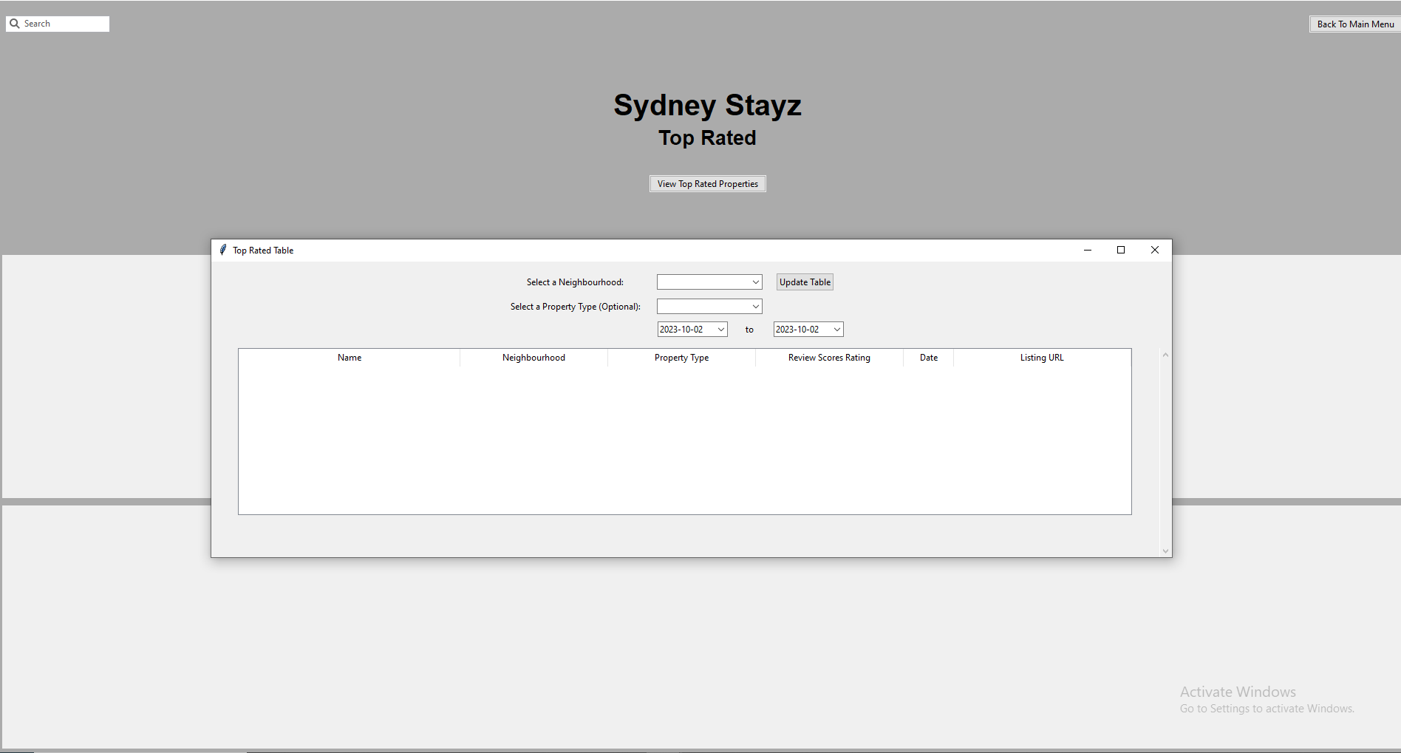

**Price Distribution**

The price distribution chart component page layout follows the standard applications colour scheme. The page slightly differs from the previous two components as the figure is not a pop-up table, but rather it is a dynamic figure embedded into the panel of the application page.

To navigate back to the main menu, a “back to main menu” button is conveniently placed on the top right of the screen. The location of this button is chosen as it is mostly universally accepted for “back” buttons to be in either the left or right top side of the screen.

There are 6 widgets which user interacts with to generate the data for the price distribution figure. The figures include:

* Suburb 1 widget drop down box
* Suburb 2 widget drop down box
* Min Value widget number input
* Max Value widget number input
* From and to date range with integrated calendar inside

The user input follows a step-by-step process to achieve a streamlined flow from start to finish.

The “Generate Graph” button is clicked to generate the price distribution figure.

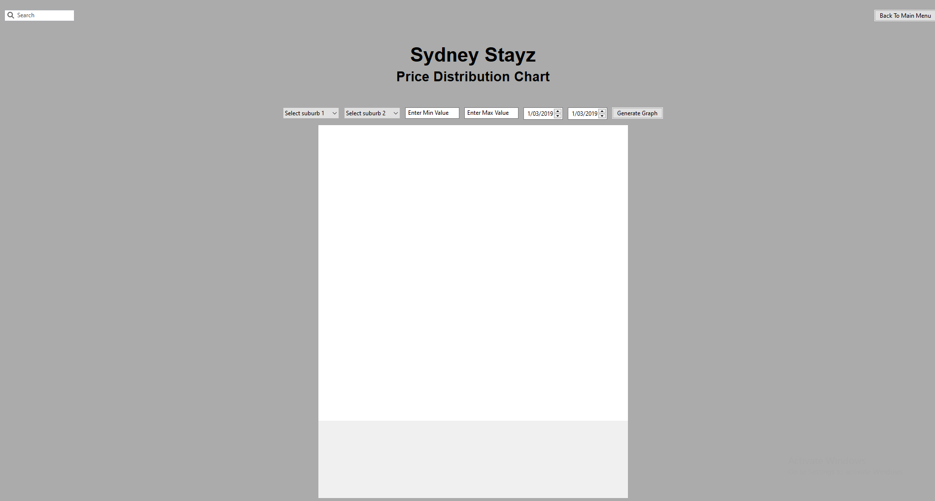

When the graph is generated, it fills the white space in the middle of the page. The graph shows a sub plot between the input data from the user. On the y axis It shows the Number of Airbnb’s and on the x axis the price. Above the graph it shows the distribution between the two Suburbs chosen, this text is dynamic as it updates based on the Suburb’s chosen. Finally, a dynamic date range which shows the dates chosen by the user.

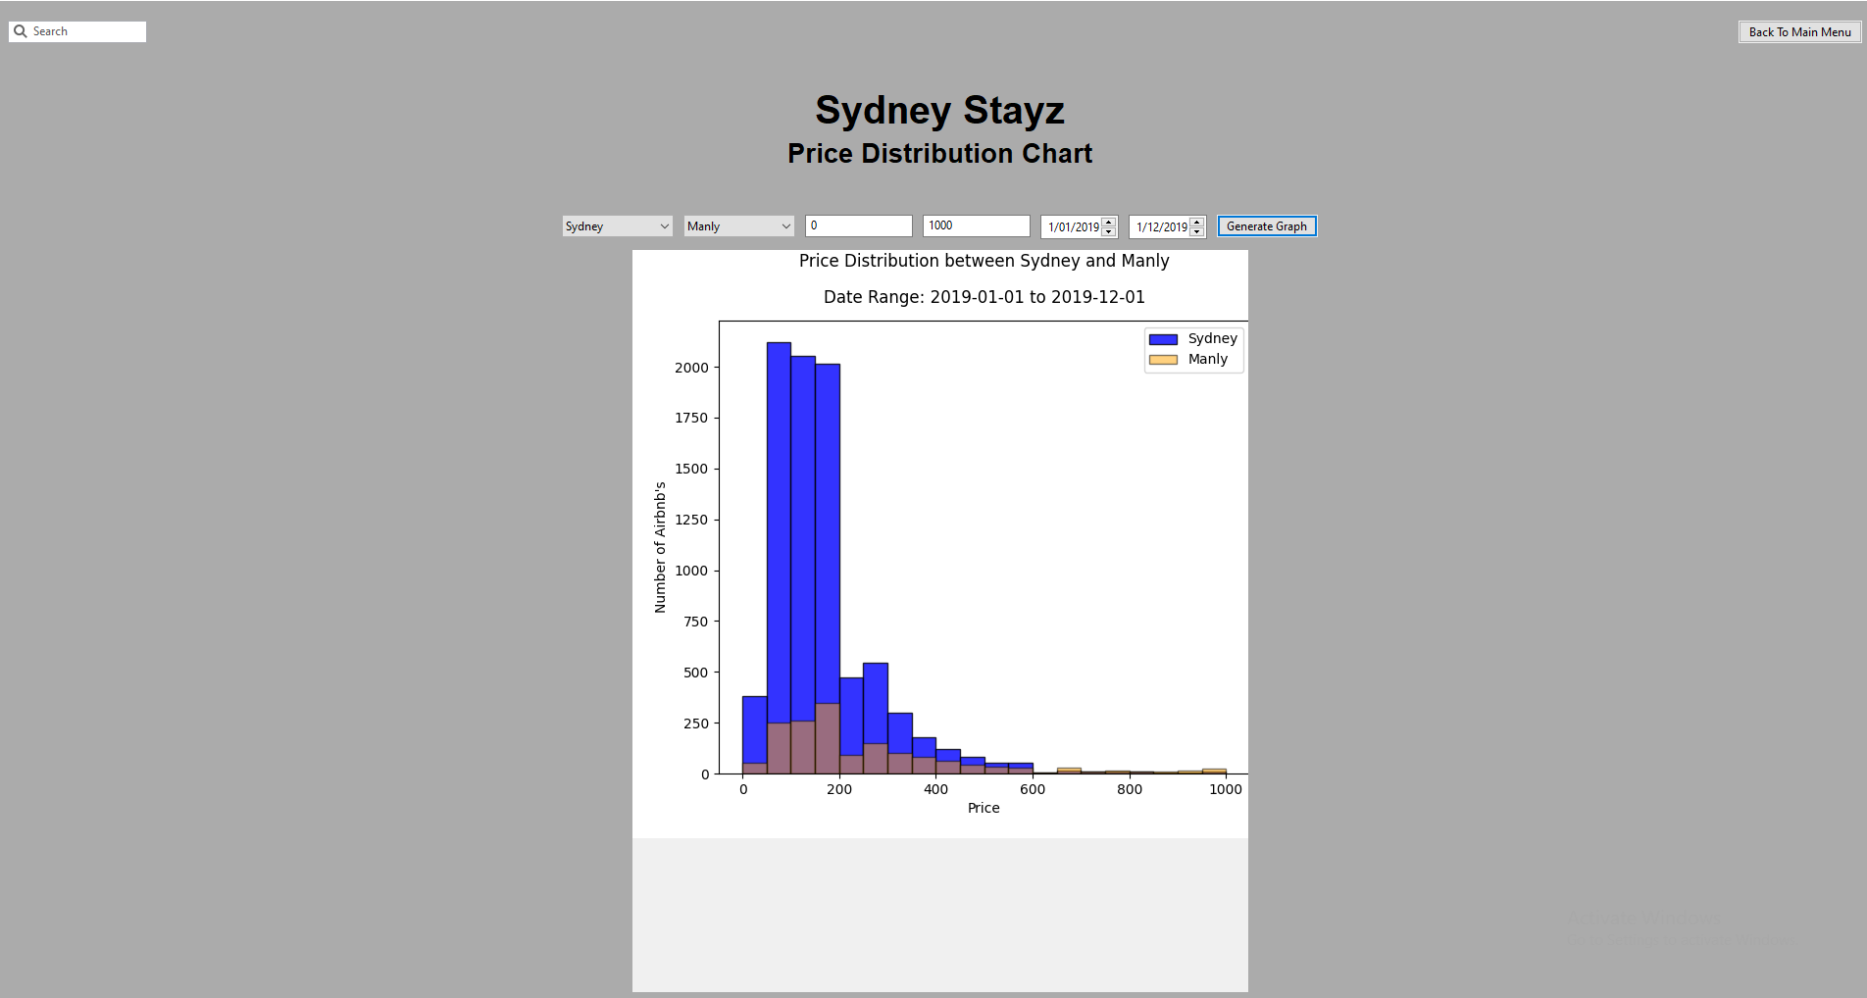

**Keyword search**

The keyword search component page follows the same colour scheme as the rest of the components and the main menu page. The page consists of a “back to main menu” button which users can navigate back to the main menu page.

Furthermore, the page consists of:

* Date range widget with integrated calendar
* Key word widget
* Confirm button

When the date range and the keyword is input, the data that matches the filters are populated to a pop-up table which is centred in the middle of the page.

